

|  |  |  |
| --- | --- | --- |
| **Supervisor** | Syed M. Aaliyan Tarique | |
| **Batch** | 2405E1 | |
| **Group** | C | |
| **Serial No.** | **Enrollment Number** | **Student Name** |
| 1. | Student1571882 | AYAN ISRAR |
| 2. | Student1571603 | OMAR AZAM |
| 3. | Student1561639 | DANIYAL ATIQ |
| 4. | Student1572461 | M. USMAN |
| 5. | Student1501129 | SUFYAN IMRAN |

Navebar:



Code:

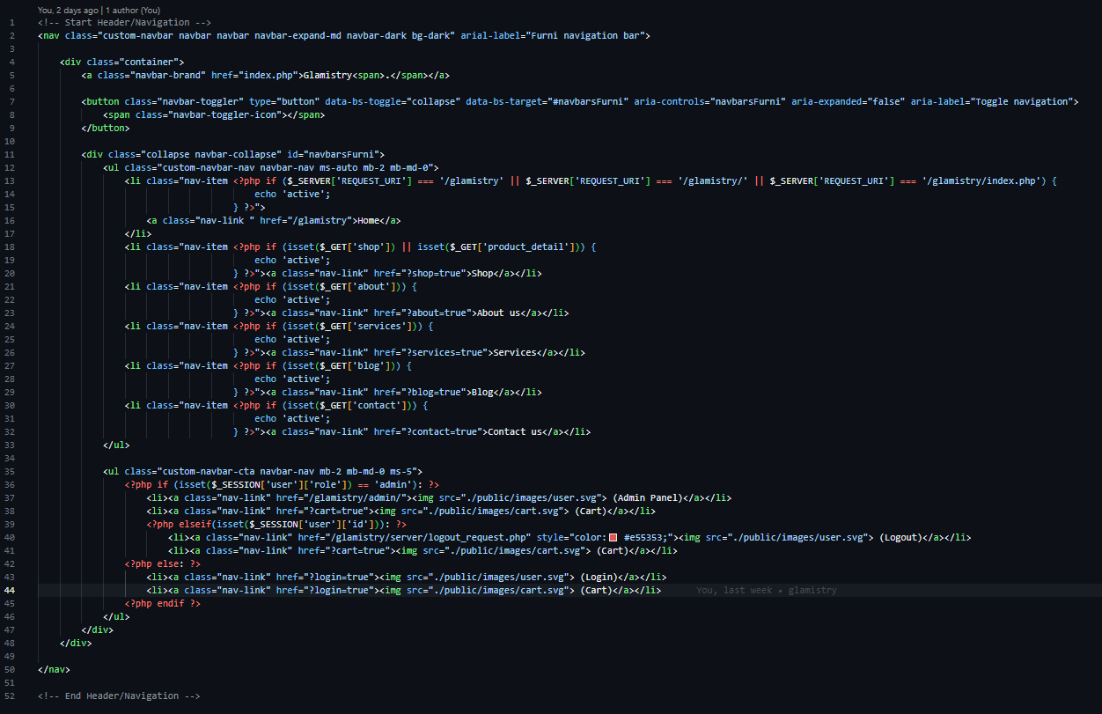

Footer:

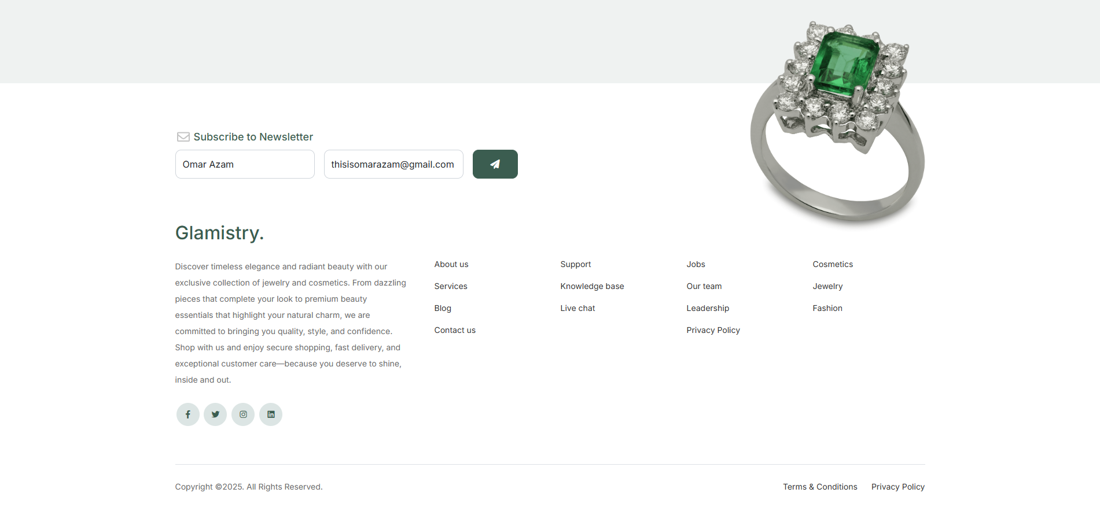

Code:

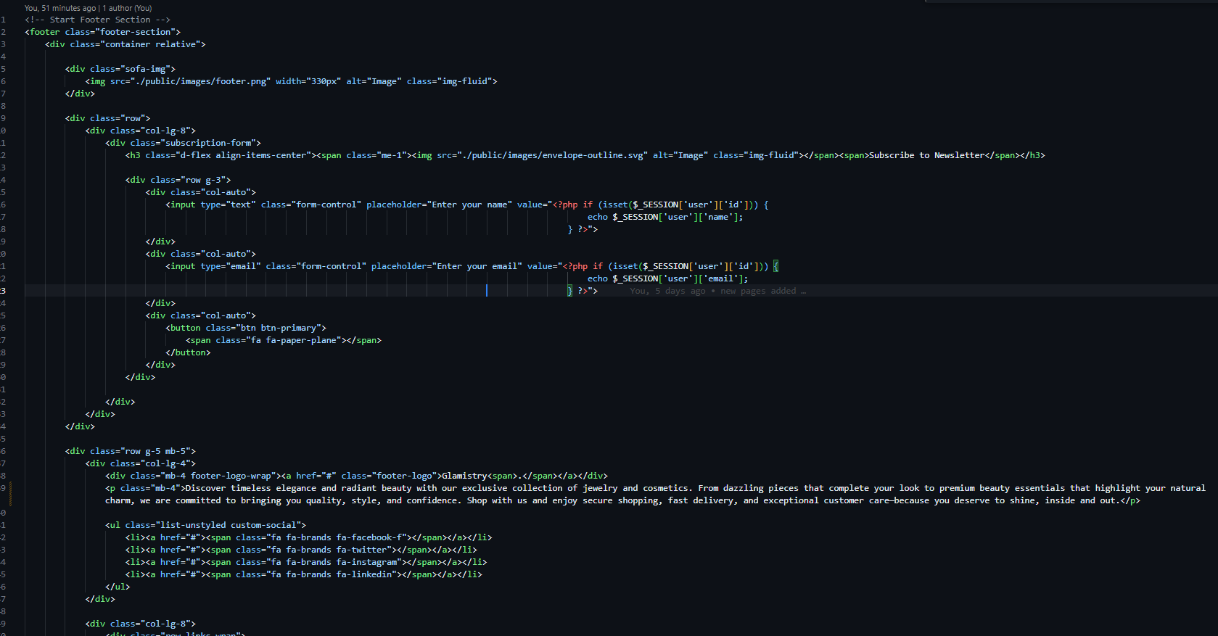

Home Page:



Code:

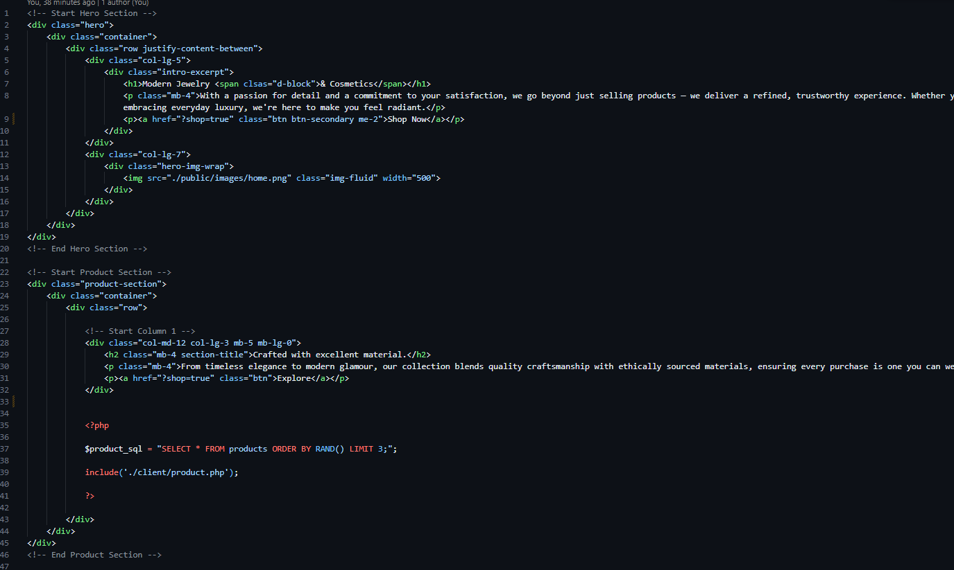

Shop Page:

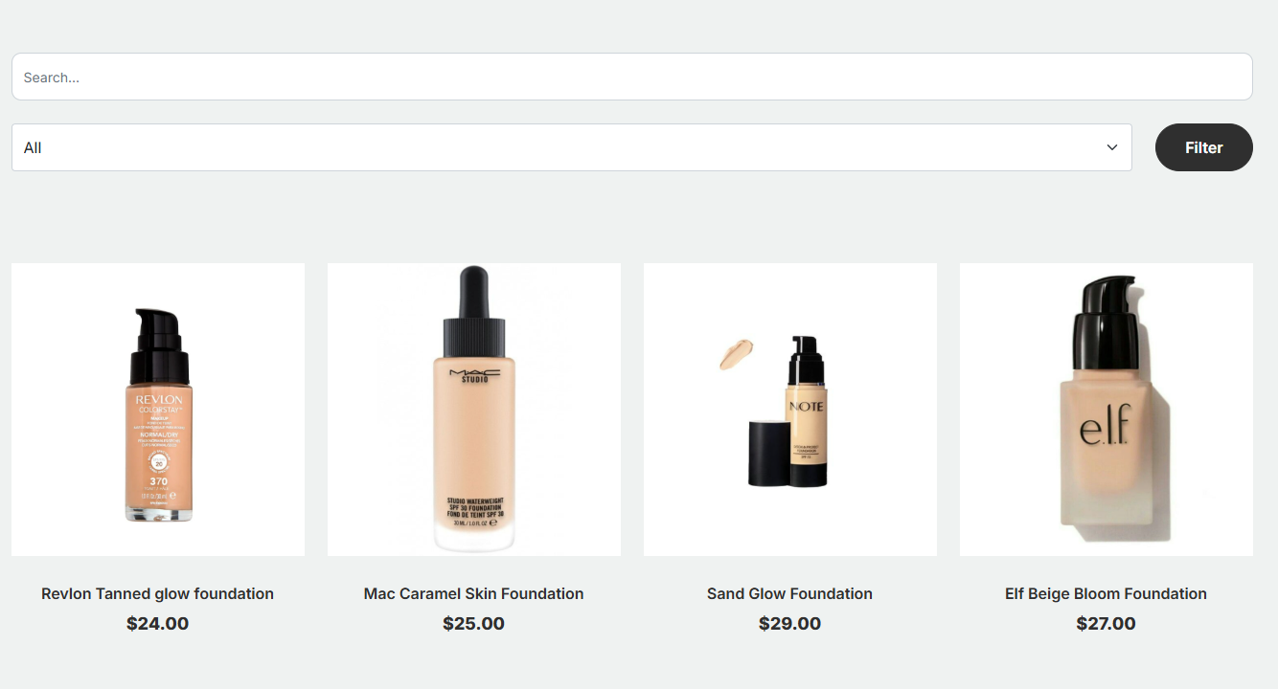

Code:

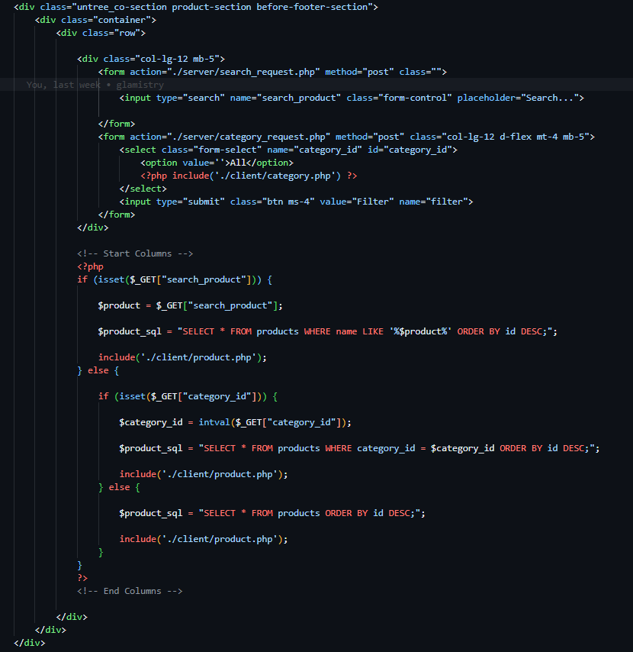

About Us:



Code:

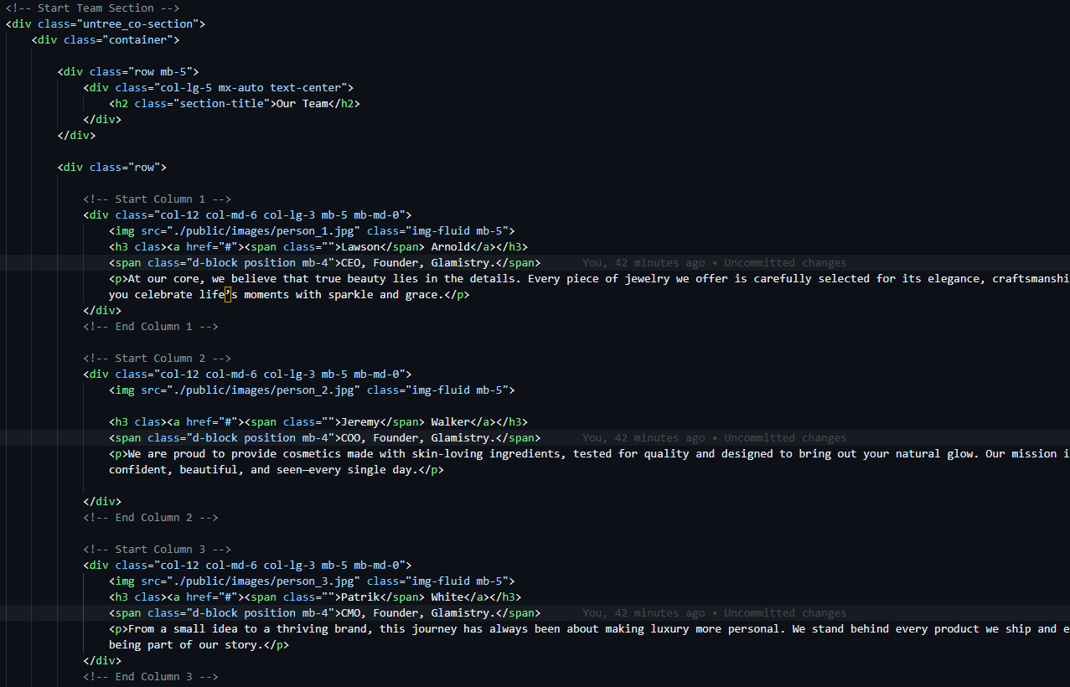

Services:

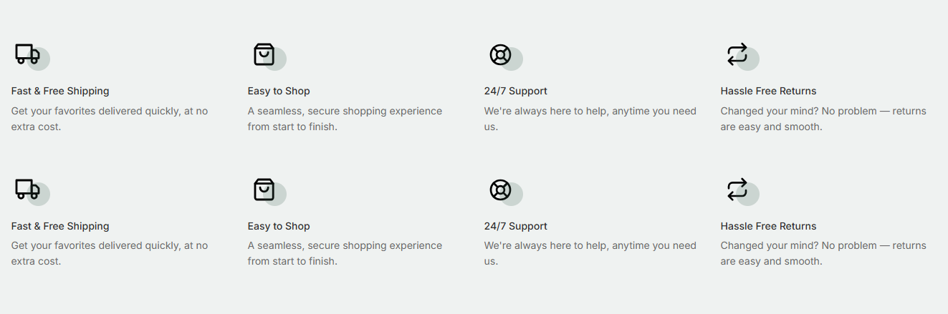

Code:

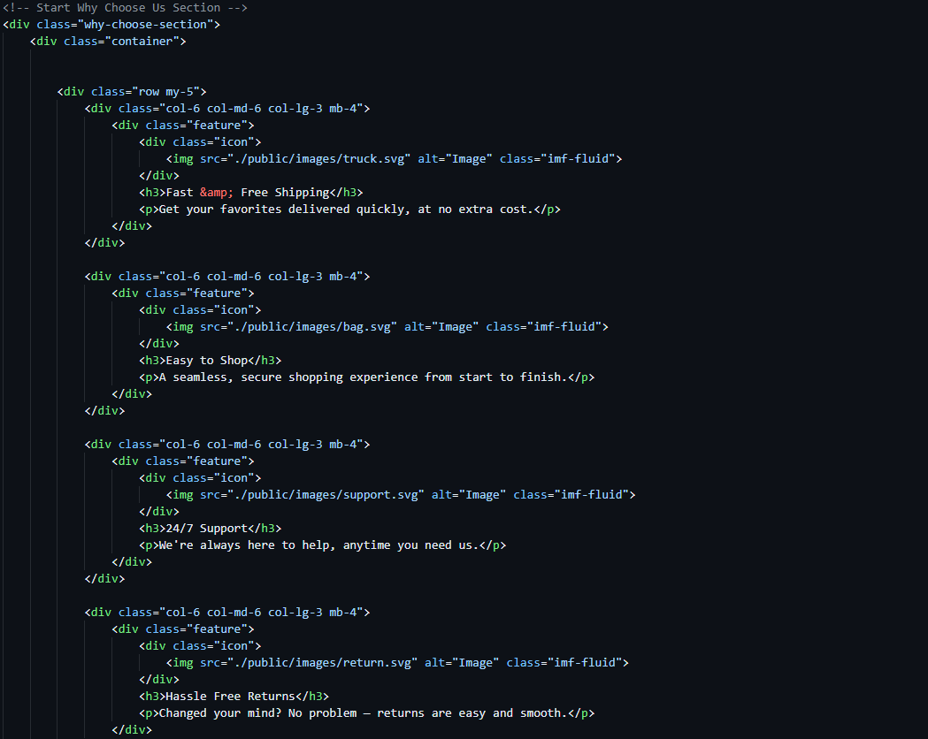

Blog:



Code:

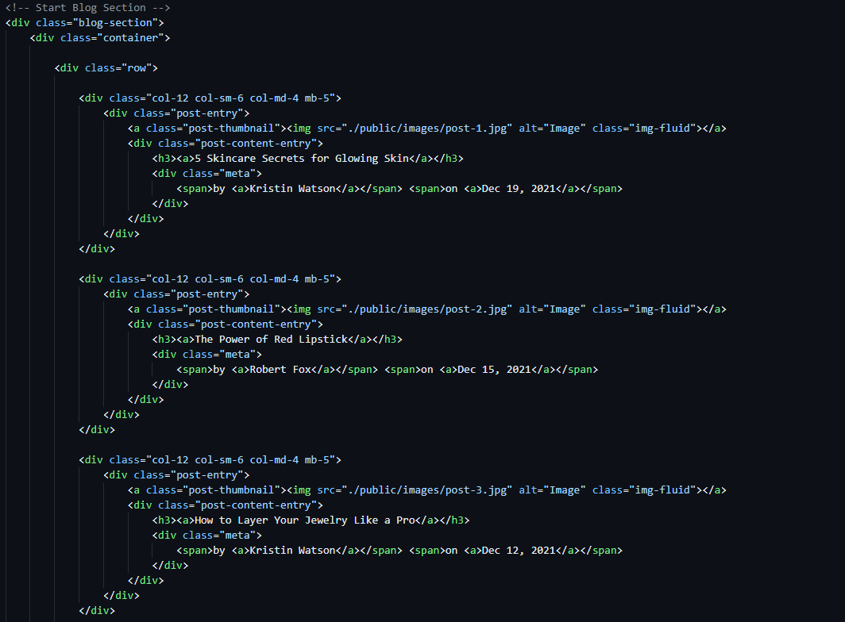

Contact Us:

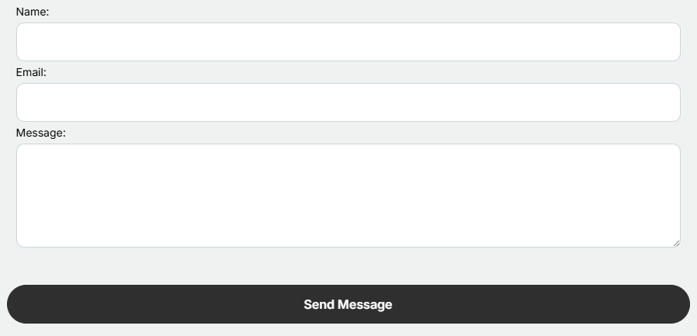

Code:

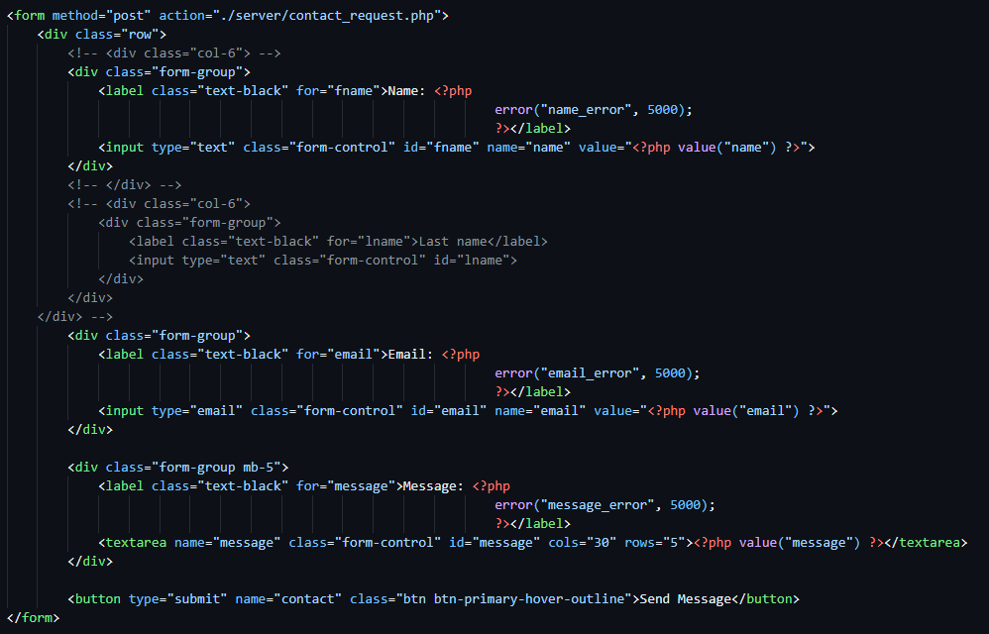

Cart Page:

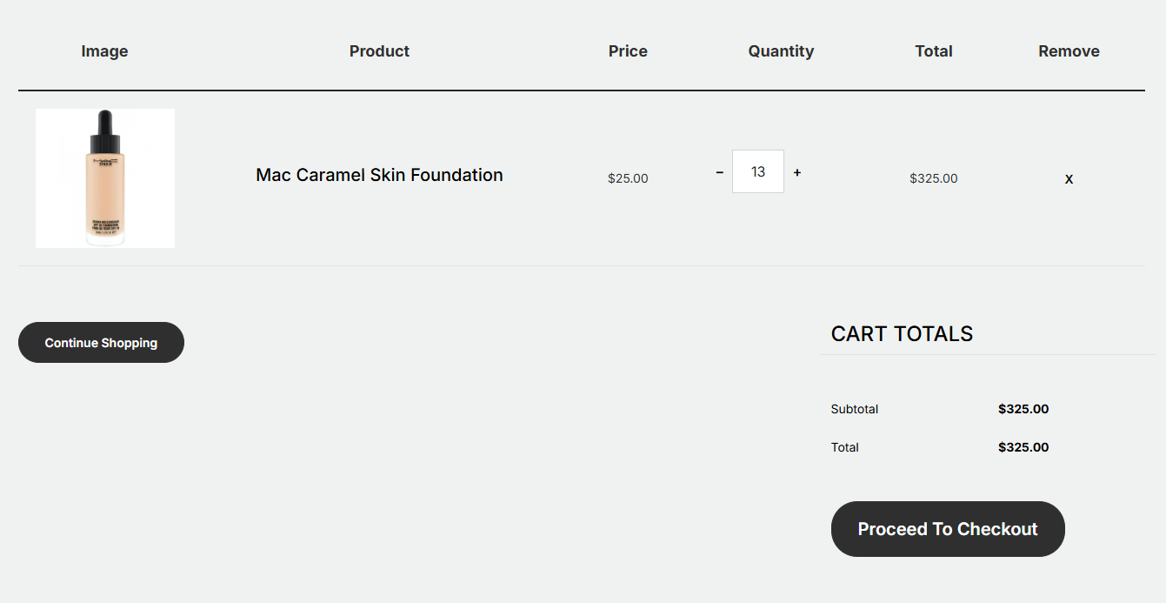

Code:

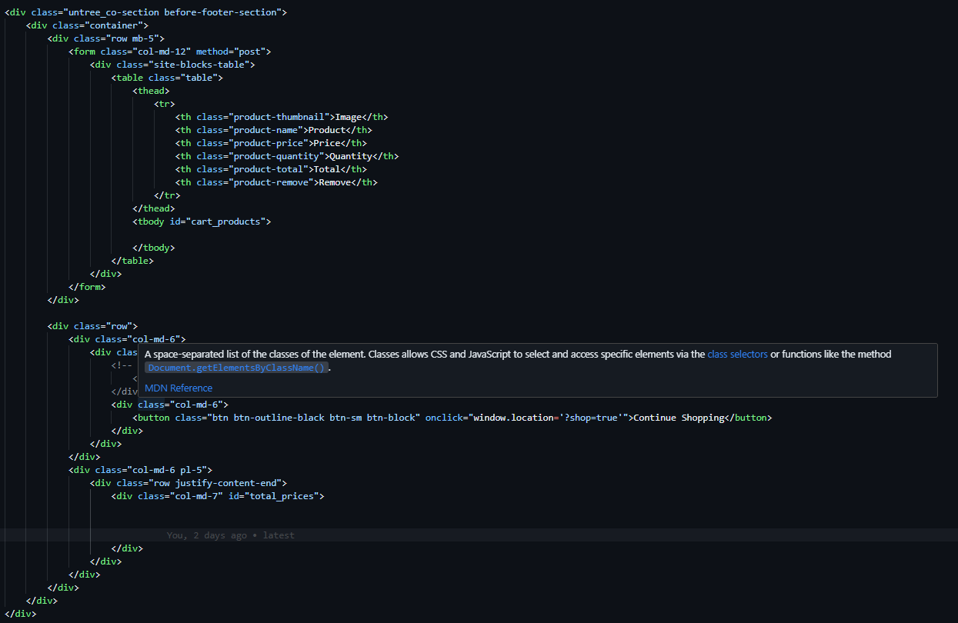

Checkout Page:

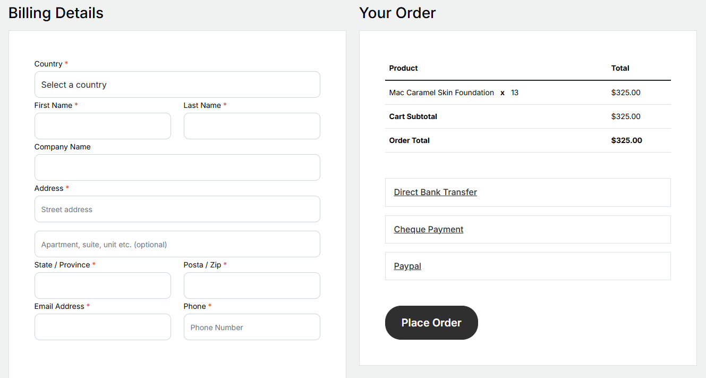

Code:

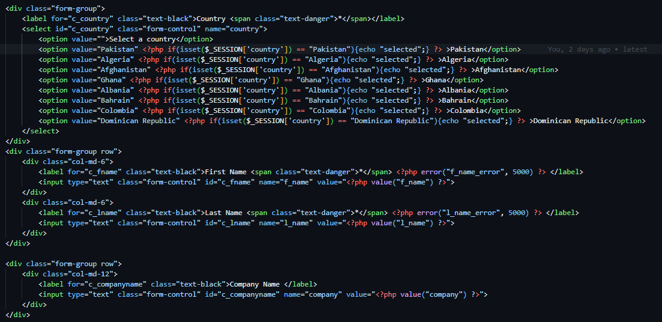

Admin Panel:

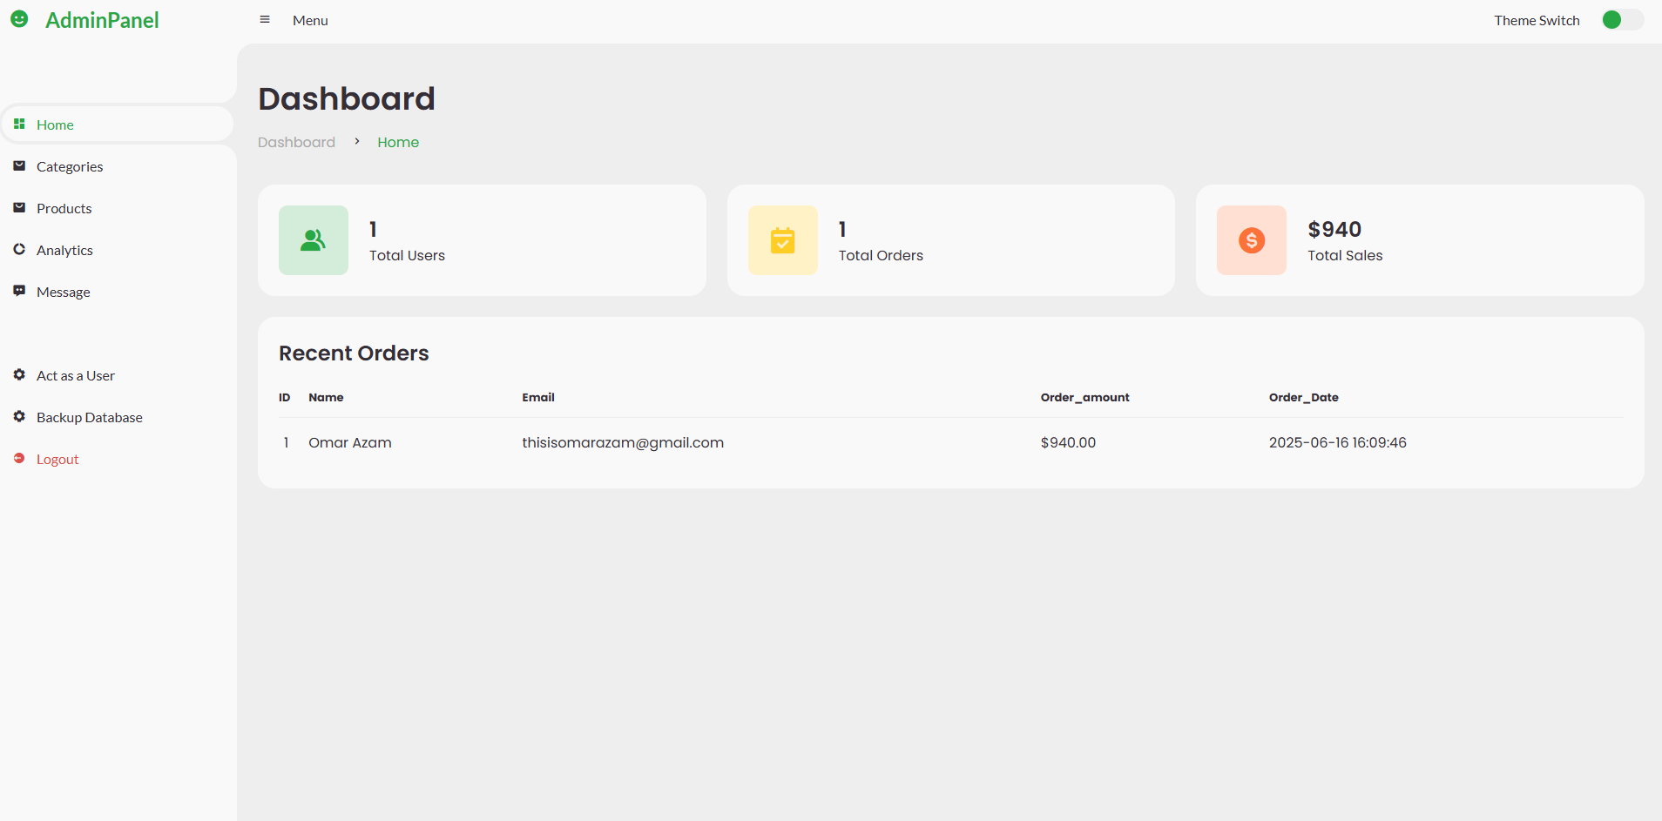

Code:

